4.1 Double Integrals

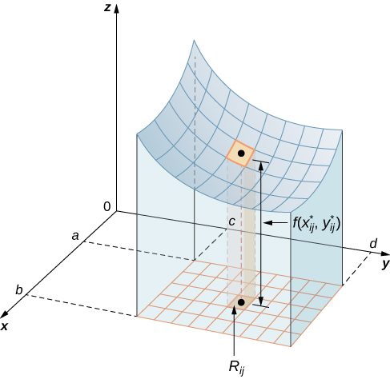
Motivation: Consider a functionof two variables defined on a closed rectangle: . Suppose that on R.

Suppose we want to find the volume of the three dimensional solid that is bounded below by R and above by the blue surface determined by f. One should note that if we allow to be negative we would be finding a signed volume.

This idea leads to the following definitions.
Definition: The (signed) volume of the solid that lies under (or over) the graph of and above (or below) the rectangle R is

Definition: The double integral of over the rectangle R is
if this limit exists.

Definition: A function is called integrable if the limit in the above definition exists.

Note: It is possible to prove (usually done in real analysis) that all continuous functions are integrable.

Example 1: Based upon your knowledge of what the double integral measures, explain in words the geometrical meaning of the quantity: .

We begin by introducing the concept of iterated integral. Then, we will make a connection between iterated and double integrals.

Definition: Suppose that is a function of two variables that is integrable on the rectangle . We refer to the following integral as an iterated integral:

Note: To find the innermost integral we view x as a constant and integrate with respect to y.
Note: It is possible that the differentials can switch positions.
Example 2: Evaluate the iterated integral (be exact): .

Example 3: Evaluate the iterated integral (be exact): .

The next theorem will explain why the iterated integrals in the first and second example have the same value. It will also be the key to connecting the ideas of the double integral and the iterated integral we have been discussing in this section.

Theorem (Fubini’s Theorem):
If is continuous on the rectangle , then
.
More generally, the above equations hold if we assume that is bounded on , is discontinuous only on a finite number of smooth curves, and the iterated integrals exist.

Proof: Beyond the scope of the course
Note: Much like the Fundamental Theorem of Calculus connects integration and differentiation, Fubini’s theorem connects the concept of double integral with the concept of iterated integral.

Example 4: Evaluate the double integral , where .

Example 5: Find the volume of the solid that lies under the hyperbolic paraboloid given by and above the rectangle .

